EU Real Estate - Due Diligence - Customer survey
Survey conducted in September and October 2020

Purpose
This survey was set to collect feedback from customers of the EU DD team, with the intention to understand our customers’ expectations, evaluate how the EU DD team is perceived by their stakeholders and identify areas of improvement in the way the EU DD team deliver their mission.

Distribution lists contacted
eu-real-estate@amazon.com (70 subscribers); eu-amzl-launch-managers@amazon.com (65 subscribers) ; whs-eu-dd@amazon.com (4 subscribers); eu-re-construction@amazon.com (66 subscribers); eu-amlz-dc-team@amazon.com (28 subscribers); eu-wwdesign@amazon.com (9 subscribers)
Number of Amazonians contacted: 242 - Number of Participants: 24 - Participation rate: 10%

Highlights
Thanks to the solid Relationship w/ stakeholders (Q14-Q24), the EU RE DD team has earned trust of their stakeholders and is regarded as a supportive (Q9), engaged and reactive team (Q19), provider of solutions.
The team’s expertise is widely recognized (Q9-Q13-Q24).
The DD team provides accurate (Q21) and comprehensive (Q13) reports, that provide good insight to stakeholders (Q23).

Low lights
Very few answers despite of 3 reminders sent. (9 TMs answered).
Despite of being comprehensive and accurate, the DD reports appear to be to sometimes unclear (Q22).
65% of participant declare having a good understanding of DD team’s role and processes (Q4), leaving much room for interpretation of DD purpose (Q5). The DD is for example expected to “solve” issues (Q25), when its purpose is to “flag” risks.
From a stakeholder standpoint, The DD team could be more flexible (Q11) and accommodating (Q18 – Q25). This is probably related to DD mechanisms recently setup (intake process) that are creating friction.
The importance of intake data quality is underestimated (70% of participant acknowledge that input quality is key to deliver robust reports).
Intake process is seen as a burden not as an opportunity to do a proper handover (Q25). Perception that the DD team innovates, but not in the interest of customers (Q15).

Key learnings
Speed is the essence (Q8-Q25). For many participants, the priority is to “get to DD approval as fast as possible” even if DD conclusions have to be ignored. The DD team needs to be more accommodating (Q11 Flexibility).
Overall the DD team workload is underestimated by 50% (Q16 - 189 active sites vs approx. 100 sites mentioned in 50% of the answers – 247 on Nov 10’2020).

Actions taken
“Action item tracker” in SHIELD to surface flagged issues and track related actions (Q7)
Review and standardize DD summary format, to improve readability (Q21 + Q22 vs Q23). (WIP)
Intake form delegated to CBRE (DE pilot – pending Approval from Infosec), at the expense of additional admin tasks for DD team. (Q25)
HLRA (High Level Risk Assessment) will be outsourced and delivered within 1 week from DD intake, to speed up site Deselection (Q8 – Q11 – Q7). WIP

Anecdotes
Ego or personal tensions have surfaced in some answers (Q25).
Interestingly, for some participants, the DD team is not seen as part of RE (Q25).

Q1 Which team do you belong to?
AMZL 8
RE 9
D&C 7

Q2 What is your job title?
D&C manager 7
Launch manager 9
Transaction manager 6
Asset manager 2

Q3 Which countries do you cover (multiple answers)?
DE 12
FRITES 6
UK 5
MENA 2
Q4 I have a clear understanding of the DD process (milestones, stakeholders and timelines)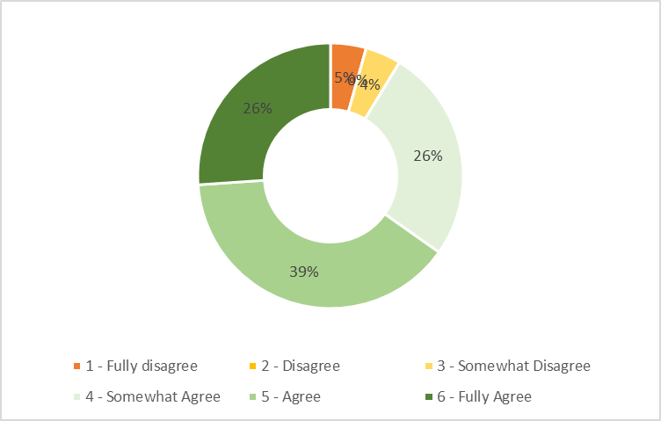

Q5 From your perspective, what is the purpose or mission of the Real Estate Due Diligence Team?
Date | Answers
Sep 22 | To understand and confirm if potential sites are the best options available, and if said options meet the requirements on operational, safety, financial... standpoints
Sep 12 | Investigating whether a property is suitable for an Amazon building with regards to permit eligibility, accessibility, traffic. But also, to check whether noise emissions could exceed the acceptable level. Furthermore, environmental criteria have to be checked. Soil investigations could be useful as from bad grounding conditions additional costs of a few millions could occur due to heavy piling requirements
Sep 12 | mission starts from to find the right plot, make permissions ready, overview the whole progress till operation starts, track return of invest (misunderstood question)
Sep 11 | ensure Amazon takes a safe place and won´t have problems in the future regarding associates, licenses or other site problems.
Sep 8 | To help to identify and analyze possible existing blockers and problems concerning the sites RE are interested in leasing or buying.
Sep 7 | DD is making sure that the additional plot ensures technical and environmental and employees health is taken care of. Amazon takes its responsibility here long-term for all leases / developments which Amazon owns or uses longer than 6 months. For less than 6 months there is a low spec DD required.
Sep 7 | To ensure the sites we take are safe and meet our operational requirements.
Sep 6 | Understanding the Amazon DD requirements and transmitting these to the operating teams. Selecting the right external consultants and negotiating prices and timing. Identifying the DDs required for each project. Instructing the consultants for the different types of DDs on each specific project. Following up each DD with the consultants, internal AMZ stakeholders (such as WHS), and the operating teams. Tracking the large number of DDs at all times thanks to reliable tracking system. Reading the DD report and summarizing these into a DD Summary that will be the basis of the DD approval. Questioning the DD results when clarifications are required. Replying to DD queries as needed. Being the reference for all risk assessments related to the physical, environmental, and planning/permitting condition of a site and its surroundings (including traffic, noise, flooding, etc.)
Sep 4 | DD Team identifyes risks in permitting, environmental, technical fields, - provides visibility on potential impact of those risks - provides recommendation on mitigation for those risks
Sep 4 | Permitting approvals
Sep 4 | Evaluate and communicate potential risks for the project execution
Sep 4 | Identify the risk on the plot and building and understand the mitigation that needs to be done. Understand impact on time and cost.
Sep 3 | To help / support to acquire sites that will work now and also in 15 years. To find sites that will ideally fit the template and allow standardized buildings.
Sep 3 | To coordinate and deliver timely DD inputs and make recommendations to resolve DD blockers on sites or buildings.
Sep 3 | To investigate sites to determine risks for Amazon in developing or operating from a specific location - and help develop mitigations for those proposed risks where they can be managed to make a site workable
Sep 3 | Make sure all potential issue is identified and if possible mitigated
Sep 3 | In most case, RE communicates directly with the DD team. I believe the main objective is to ensure that the DDs conducted for AMZL are aligning with WW standards. RE DD-Team challenges various topics to ensure that the project is feasible.
Sep 3 | To provide a realistic feedback on the likelihood that a project is deliverable within a certain deadline
Sep 3 | To make aware on potential risks for sites we are looking into.
Sep 1 | To provide information on a building or plot in which Amazon Real Estate are wishing to lease or purchase, giving the business clear line of sight on any issues that could restrict the use of the building for our operations or provide a safety risk to our associates.
Sep 1 | Site feasibility
Sep 1 | To analyze all potential risks that can jeopardize the success of the project.
Sep 1 | To accurately and promptly provide relevant feedback in order to advise us on the feasibility of a site, and to suggest mitigation to D&C and the developer if certain aspects are lacking.

Q6 Overall, are you satisfied w/ the work delivered by the DD team?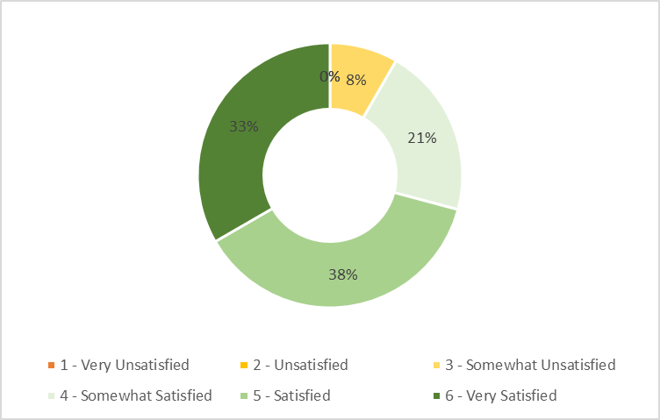

Q7 What deliverables do you expect from the DD team?
Date | Answers
Sep 22 | Feedback and guidelines on sites audited and proposals for alternatives or adjustments.
Sep 12 | Testfit in 2 different scales, 1. testfit showing the plot itself, 2. testfit showing the surrounding area with the next highway connections, possible bicycle ways, public traffic possibilities Permitting report Traffic survey Noise emission report Environmental report Geotechnical report
Sep 11 | Quick actions and easy process. Also, good communication. Everything related to DD is changing a lot in the last months and it´s being very difficult to understand the why of the changes. Also, we need you and approvers are flexible and look the overall of the situation and not just a report.
Sep 8 | I expect technical support and assistance to assess the sites in a timely manner
Sep 7 | Clear intake and timescale in early days
Sep 7 | Quick responses, guidance on technical matter when required. Support to meet deadlines for reports
Sep 6 | Help with defining the required DDs Timing estimates. Thorough tracking of the DD. Warn the business as soon as a problem is uncovered. Provide judgement in special situations. Propose pragmatic solutions in difficult situations
Sep 4 | High Level Due Diligence and the rest of DD (EDD, TDD, Permitting DD)
Sep 4 | Permit tips and give directions on what is allowed or not.
Sep 4 | Quick red flags to disregard potential projects that are not feasible in first place. Clear guidelines on how to proceed with a moderated risk in second place.
Sep 4 | Clearly explain risks in the summary and suggested mitigation.
Sep 3 | All that you already provide. DR0 compliance documents. no additional needs.
Sep 3 | To identify/call out key issues as early as possible. To meet DD report milestones. To pro-actively push consultants to achieve milestones.
Sep 3 | Reports on time and more importantly help with coming up with mitigations to the risks identified with the reports
Sep 3 | A non-technical summary of the finding + a propose mitigation plan Solution oriented approach
Sep 3 | Clear results in a reasonable time
Sep 3 | Clearly structured easy to capture reports
Sep 1 | Clear reports that are shared with stakeholders giving a summary of points to be aware of during the development process, within the appropriate time to maintain programmed building launches.
Sep 1 | meeting 4-week timescales.
Sep 1 | Proactiveness with solving amber/red flags. Lead to get DD approval asap.
Sep 1 | Clear and succinct reports and recommendations without too much hedging [?].

Q8 When requesting support from the DD team, I am confident that summary and reports will be delivered on time.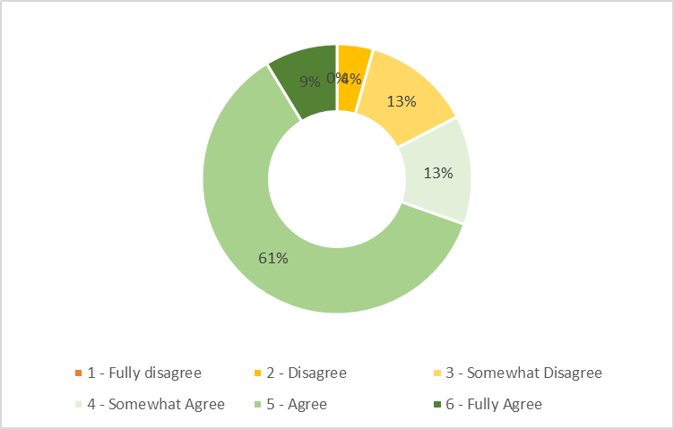

Q9 When requesting support from the DD team, I am confident that outputs will be reliable and will support the site selection process.
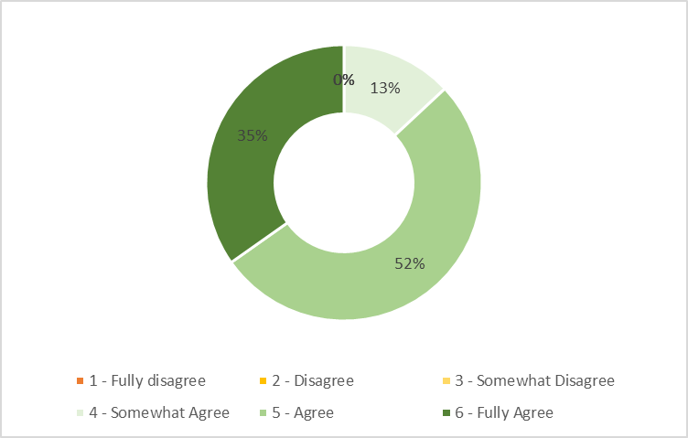

Q10 When requesting support from the DD team, I am conscious that the quality of the DD reports relies fully on the intake data submitted
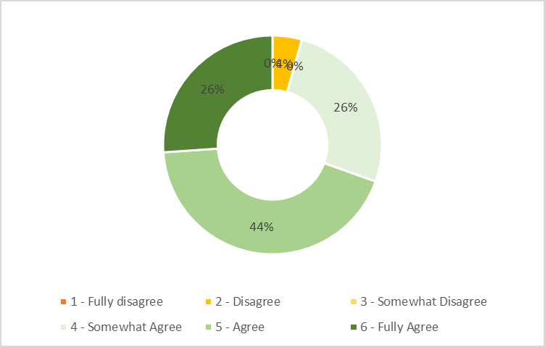

Q11 The DD Team works with a great deal of flexibility so that we can adapt to changing needs
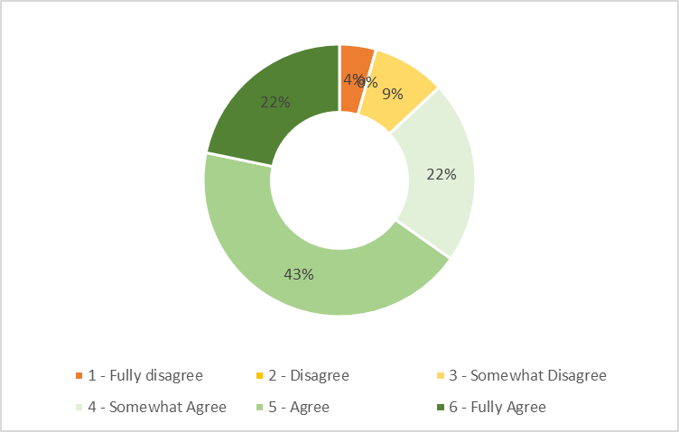

Q12 I have established trusting and supportive relationships w/ the DD team
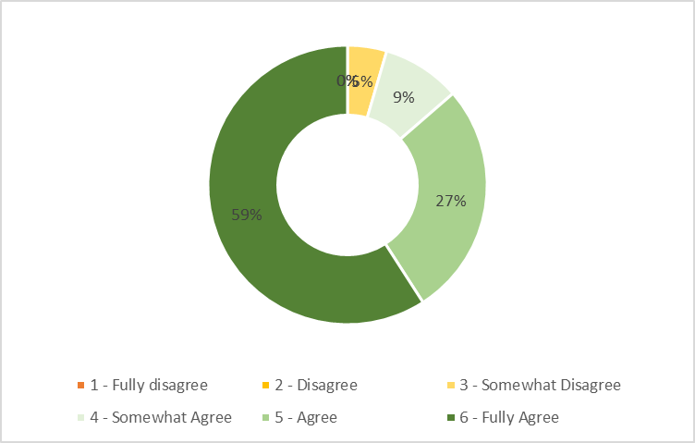

Q13 The DD team members provide solid judgment and expertise. I trust their initial assessment of risk.
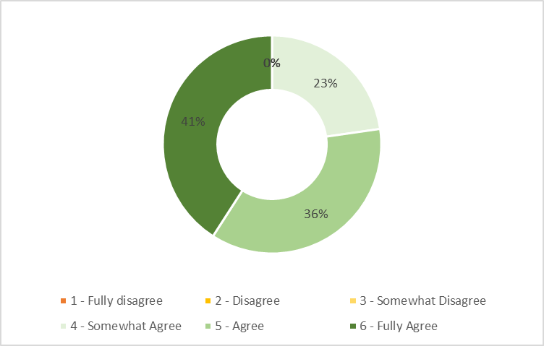

Q14 The DD Team maintain a can-do approach, even when they encounter frustrating situations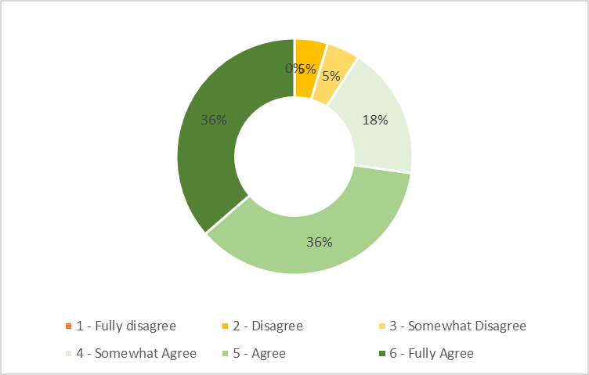

Q15 The DD team look for improvements and innovations. They question their process, purpose and tools.
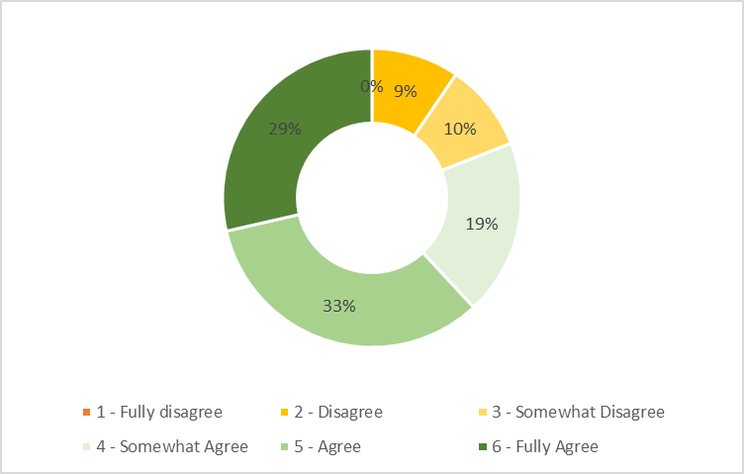

Q16 How many sites does the DD team survey across EU at in given time ?
Date | Answers
Sep 22 | Probably close to the thousands, I know the workload is very high.
Sep 12 | more?
Sep 12 | 100
Sep 11 | small sites...150 big sites no clue
Sep 8 | 100???
Sep 7 | I don’t get that question. Which given time? Sorry I am lost in translation.
Sep 7 | 80
Sep 6 | 200
Sep 4 | 189
Sep 4 | 64
Sep 4 | 50
Sep 3 | 100
Sep 3 | 100
Sep 3 | I don’t know
Sep 3 | as much as the numbers of stars in the sky
Sep 3 | 70
Sep 3 | 150
Sep 3 | 120
Sep 1 | Probably around 100
Sep 1 | 100
Sep 1 | same number of projects as all of us
Sep 1 | 100
Sep 1 | 150

Q17 The DD team focus on big-picture strategic issues as much as on critical detail points.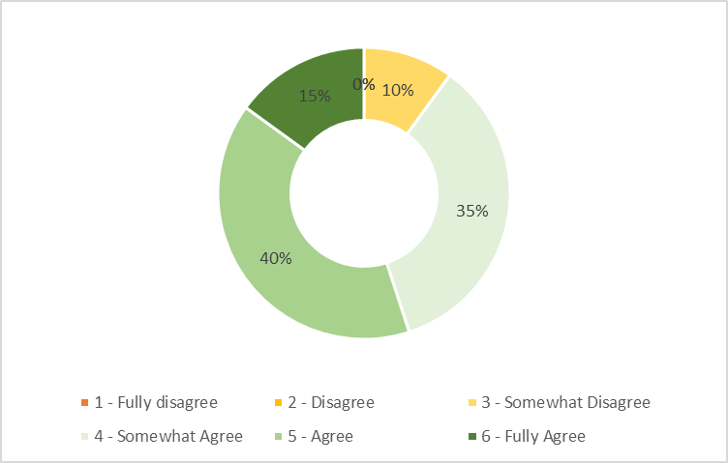

Q18 The DD Team members frequently go beyond what is required and do not hesitate to take initiative or new responsibilities.
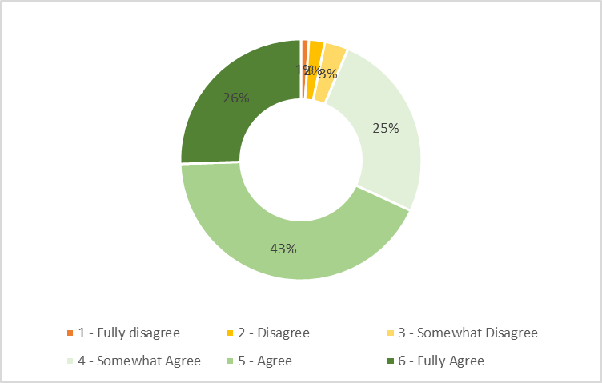

Q19 The DD Team is reactive when asked to adjust their scope or to accelerate DD delivery, whenever possible.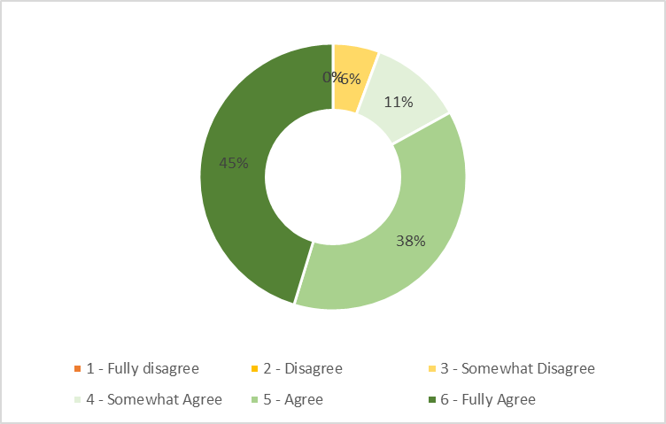

Q20 The DD team express their concerns and disagreement in a constructive & candid way?
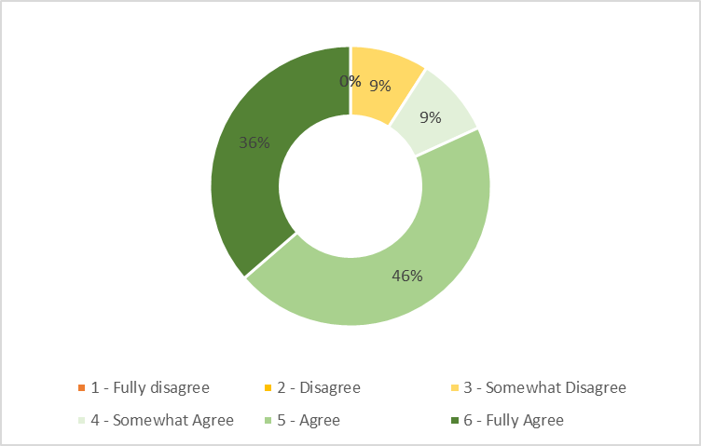

Q21 DD reports are accurate and comprehensive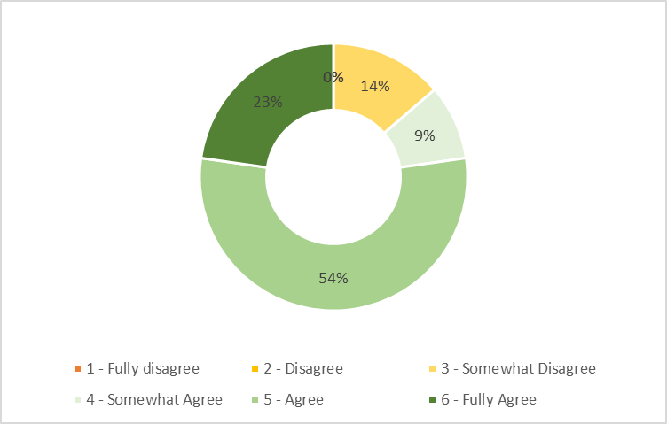

Q22 DD reports are clear, concise and to the point. 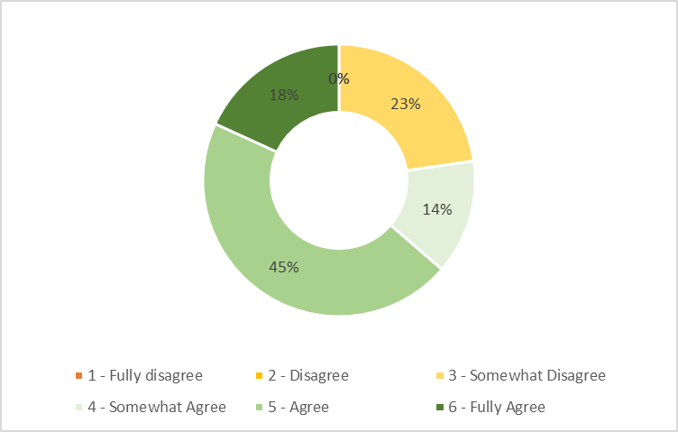

Q23 DD Approvals are clear and provide good insight.
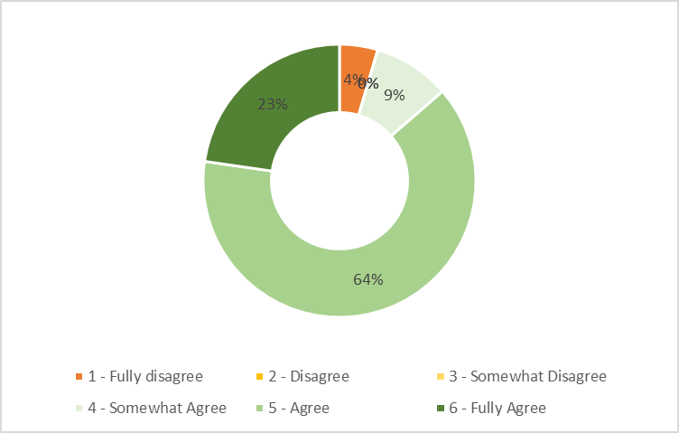

Q24 With the DD team, what works well ?
Date | Answers
Sep 22 | I never feel like hesitating contacting the DD team because I know they will be nice to me, give feedback in a constructive way and propose solutions when facing an issue. It's the biggest relief to know beforehand that you will work with people willing to support you and working with a positive attitude.
Sep 12 | Always cooperative and responsive
Sep 12 | to show summary of the progress with necessary details
Sep 8 | usually they are very responsive and try to solve problems
Sep 7 | more transparency and process guidance available now, thank you!
Sep 6 | Flexible, efficient team, are an important part of the deal, participate in the successes and the failures
Sep 4 | Traffic Simulation, Traffic Studies
Sep 4 | The reports are very complete
Sep 3 | DD presentations and weekly calls to align on projects. Delivering solutions to DD/WHS issues.
Sep 3 | The DD presentations from the consultants where we also have developers on
Sep 3 | They are proactive and solution oriented
Sep 3 | The DD managers that I work with are always available in explaining what is not working and helping me out in finding the right key to solve the issues
Sep 3 | Clarifying on follow up questions.
Sep 1 | Engagement with construction teams has really improved particularly in the UK in the last six months, Construction Managers are being invited to the DD instruction and feedback calls and now have clear line of site on timing and output of reports.
Sep 1 | onboarding calls.
Sep 1 | The DD team is my favorite team. They are very customer oriented and always helpful. Thomas and Tehya are the best! They really raised the bar.
Sep 1 | Responsiveness and flexibility

Q25 Anything that the DD team could improve?
Date | Answers
Sep 12 | Always check the input for the respective template (particularly traffic numbers from the latest BRS) Very often the truck numbers did not comply with the BRS requirements. Highway connections to be presented
Sep 12 | Nothing
Sep 8 | sometimes they do not realize the need to go ahead with a certain site, due to the lack of other suitable sites, as well as the urgency to sign the contract. More flexibility and out of the box thinking would be much appreciated here
Sep 7 | No recent touchpoints as team recently changed completely.
Sep 6 | Time is never in favor of the TM. Sometimes we need to accelerate processes, and although DDs take long, it would be good to source special case, expedited services (even if much more expensive) when time is of the essence and the deal is critical to the business.
Sep 4 | Environmental DD recommendations.
Sep 4 | prioritize and send quick red flag reports.
Sep 3 | The DD approval process is currently launched by RE TM's. The DD team may be better placed to run this process.
Sep 3 | The very painful intake process. Also - there is no tracker for the issues raised in the DD - to confirm if they are solved in some way
Sep 3 | not as I know
Sep 3 | Raising awareness in the consultants about the importance of time for us. The consultants shouldn't wait until the reports to show the lack of documents from the developer. This will certainly slow down the process and the overall negotiation.
Sep 3 | Simplify the intake process
Sep 1 | Some of the DD consultants are beginning to struggle with the sheer volume of work and reaction times are therefore starting to manifest in delays to the development program. Options are required as back up for certain functions when we are reliant on one supplier within a specialist function for reports.
Sep 1 | Two things. At the moment we are going the wrong direction with the innovations. I see you are trying to make your process better but me as a customer I’m unsatisfied. First You started to raise the POs and only after that confirming the presentation dates. Before, I knew the date immediately, now I need to wait a week to be able to update my customer. I receive worse service than before. In my view we created a waste because you do some work which is not helping me, the customer. Second, New intake form is another waste. CBRE used to do this for us. With all number of projects, I really don’t want to spend time filling up the intake forms. Please be proactive and find the information yourself if anything is missing. Many thanks for asking for our opinion, even though I find the questionnaire a bit weird.
Sep 1 | Be responsible for the DD approval process. After DD completion sent out a recommendation on next steps to overcome amber/red flags.
Sep 1 | We need to ensure that CBRE can access and populate DD intake. The RE team is the customer and should be treated as such.

Q26 How would you rate this survey? 